**Hands On Assessment ML**

**Yashaswi Singh**

**Data Preparation:**

1. Selecting the Age, AnnualIncome and SpendingScore column and not including the customerId column for the machine learning

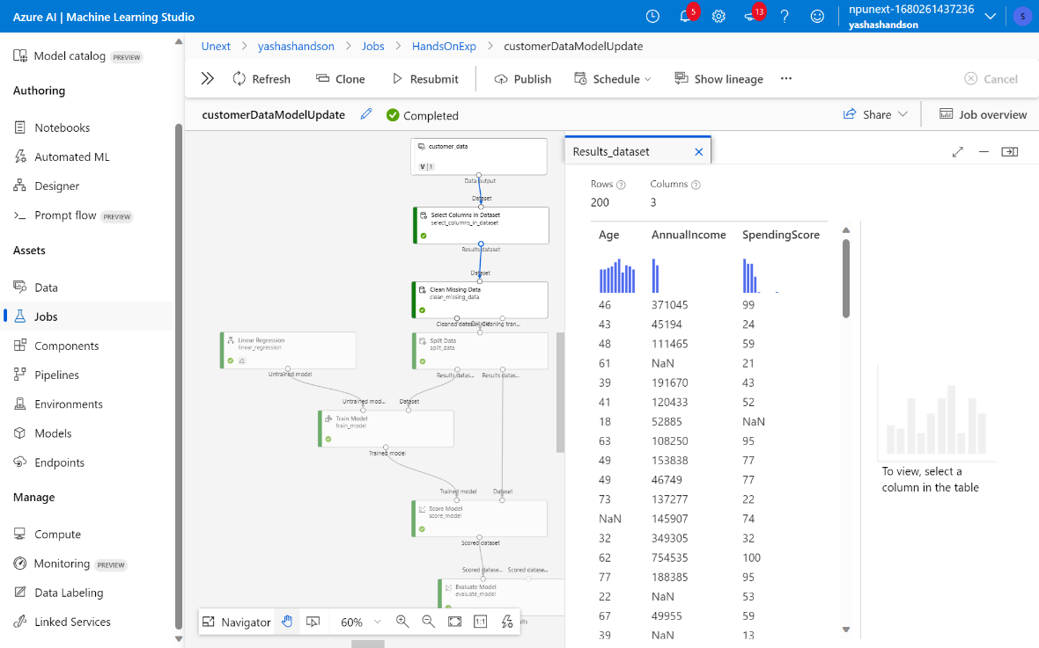

b. Cleaning the missing values using Clean Missing Data component

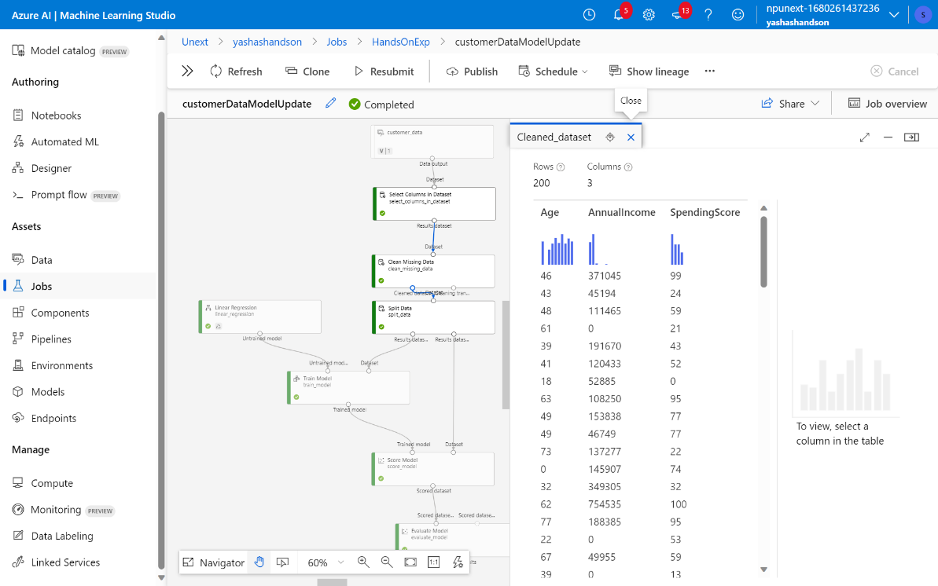

**Model Development:**

1. Splitting the data set into 70% training and 30% testing data set. The ML model used in this case is Linear Regression.

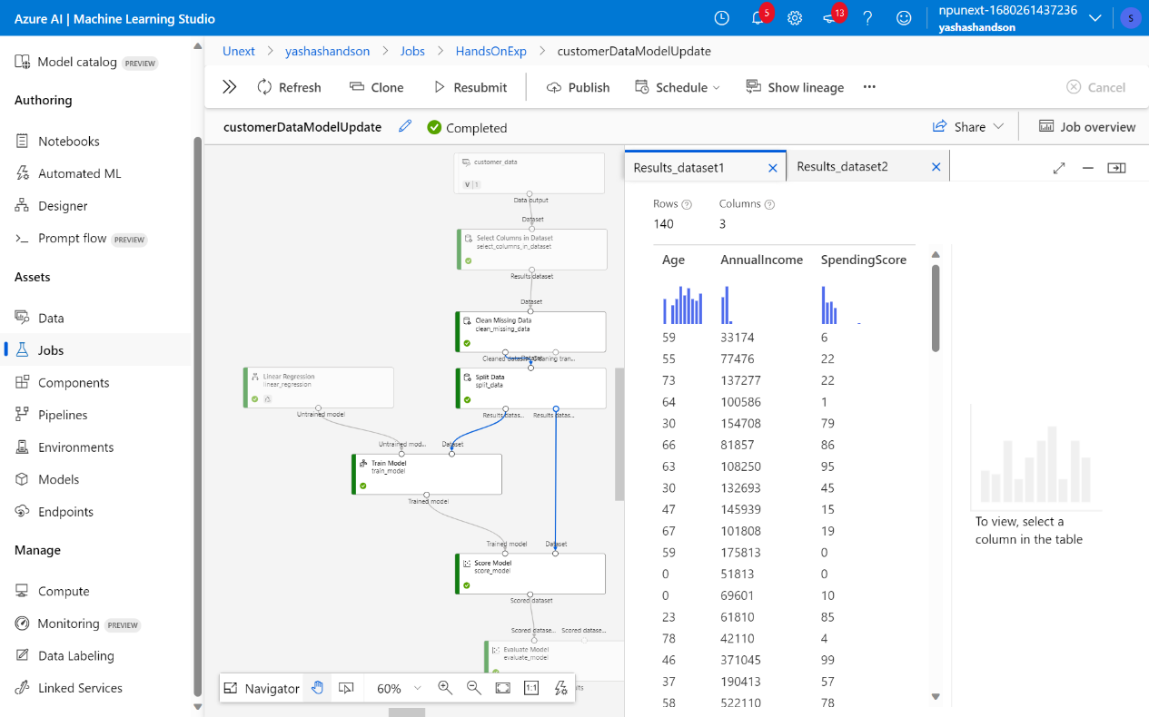

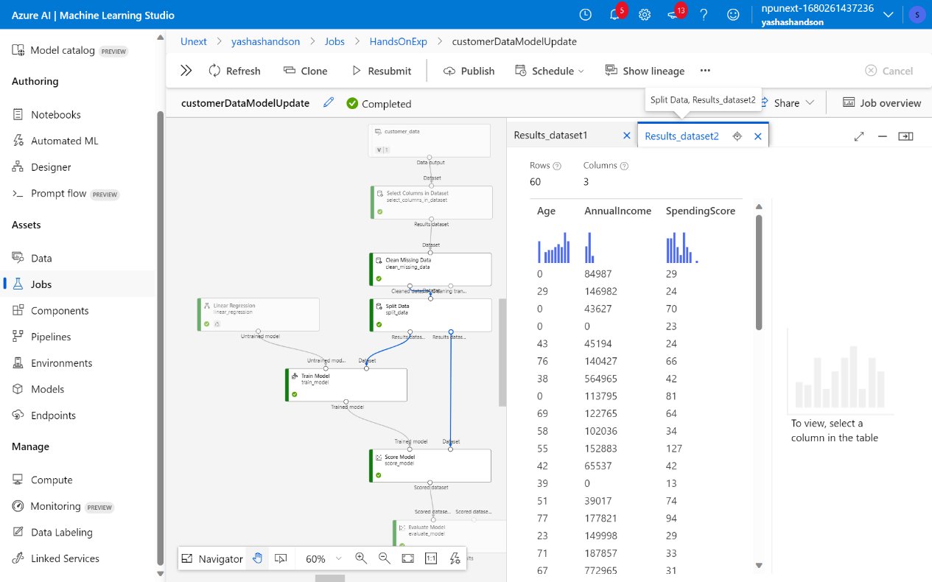

**Results:**

1. Training Model

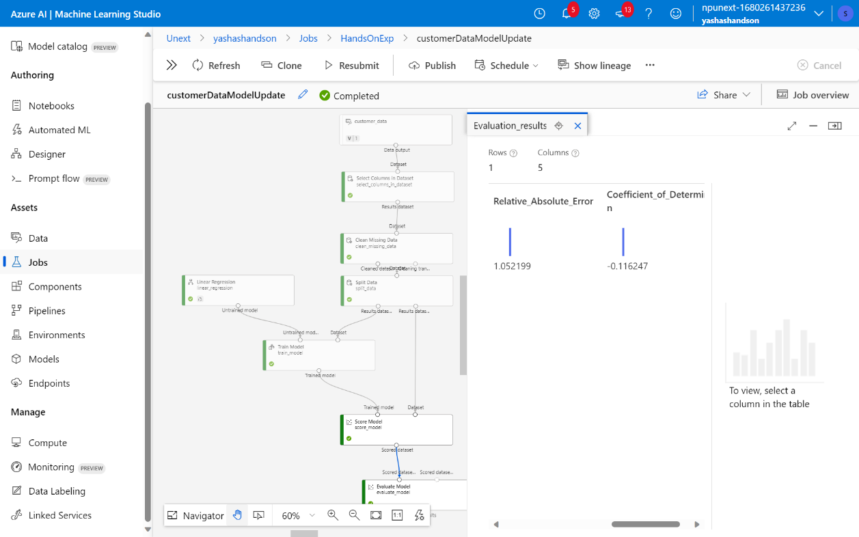

1. Hypeparameter

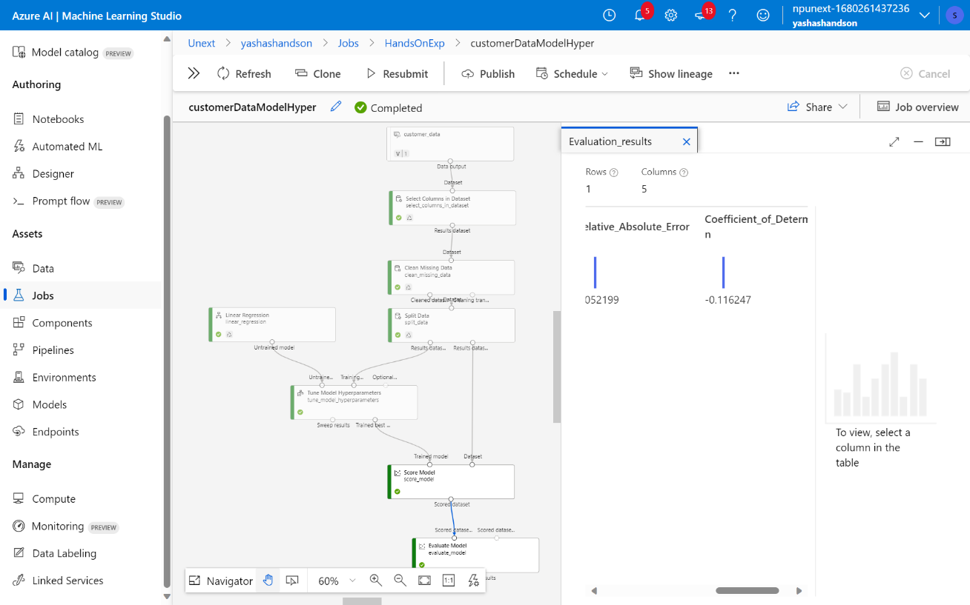

Assessment Questions:

1. What are the key steps involved in preparing the dataset for training a machine learning model using Azure Machine Learning? Briefly explain each step.

**Ans: Removing the unwanted tables and cleaning the bad or missing data.**

2. Why is it important to split the dataset into training and testing sets when developing a machine learning model? How does this help in model evaluation?

**Ans: Spliting the dataset ensures that after training the model we have data to test it on and hence we can check the accuracy of the model since we already know the answer. This also helps in preventing over and under fitting.**

3. Describe a machine learning algorithm suitable for predicting customer purchasing behaviour in the given scenario. Explain why you chose this algorithm.

**Ans: Linear Regression is the most suitable because it helps in prediction of a parameter based on the previously fed data.**

4. What is hyperparameter tuning, and why is it important in machine learning? Explain a technique used for hyperparameter tuning and its benefits.

**Ans: Hyperparameters are used in machine learning by users to give us control over the machine learning algorithm.**